**Module 11 Assignment**

**An Analysis of Martian Data**

From the analysis of the Martian data, we can conclude that there are 12 months in a year on Mars, which is like Earth. The total dataset was obtained over 1867 sols, a term for the Martian equivalent of a day.

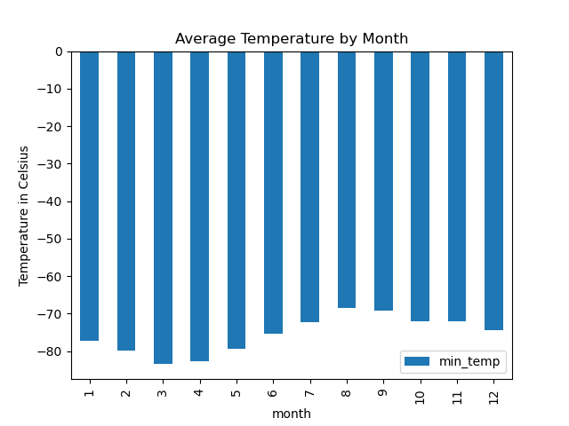

Figure 1. A chart showing the minimum temperature for each month on Mars.

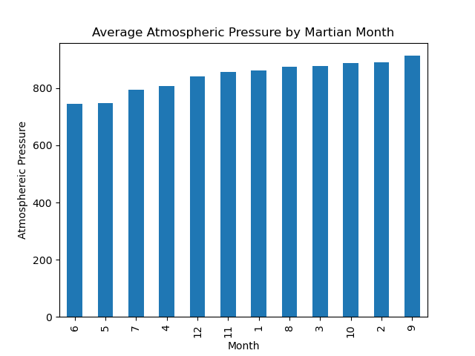

Figure 2. A chart showing the average atmospheric pressure on Mars each month.

From Figure 1, it can be ascertained that temperatures plummet to quite frigid and freezing temperatures overall, with the 8th Martian month being the warmest and the 3rd month being the coldest. The trend in Figure 2 shows the average atmospheric pressure for each Martian month. The 6th Martian month has the lowest while the 9th month has the highest atmospheric pressure.

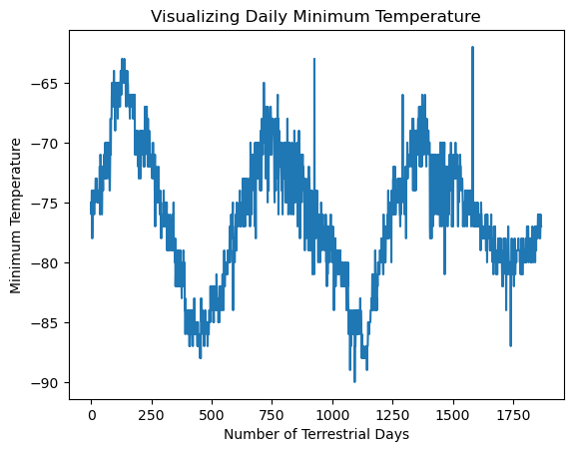

Figure 3. A chart showing the daily minimum temperature on Mars.

1100-450 = 650

Figure 3 is an exciting line graph showing the daily minimum temperature on Mars. If we take the same trough from the cyclical trend, there are roughly 650 terrestrial days in a year on Mars.